GEMINI HISTORICAL ARTIFACT DESCRIPTION

A Project Report
On
Gemini Historical Artifact Description

Submitted by

22HM1A0545 - J.AMRUTHA LAKSHMI

1

LIST OF CONTENTS

CHAPTER NO NAME OF THE CONTENTS PAGE NO
LIST OF CONTENTS 2-3
CHAPTER 1 INTRODUCTION 4-5
1.1 Project Overview 4
1.2 Purpose 5
CHAPTER 2 IDEATION PHASE 6-9
2.1 Problem Statement 6
2.2 Empathy Map Canvas 7-8
2.3 Brainstorming 8-9
CHAPTER 3 REQUIREMENT ANALYSIS 10-16
3.1 Customer Journey Map 10-11
3.2 Solution Requirement 12-13
3.3 Data Flow Diagram 13-14
3.4 Technology Stack 15-16
CHAPTER 4 PROJECT DESIGN 17-21
4.1 Problem Solution Fit 17-18
4.2 Proposed Solution 18-19
4.3 Solution Architecture 20-21
CHAPTER 5 PROJECT PLANNING & SCHEDULING 22-23
5.1 Project Planning 22-23
CHAPTER 6 FUNCTIONAL AND PERFORMANCE
TESTING 24-25
6.1 Performance Testing 24-25
CHAPTER 7 RESULTS 26-29
7.1 Output Screenshots 26-29

CHAPTER 8 ADVANTAGES & DISADVANTAGES 30
CHAPTER 9 CONCLUSION 31
CHAPTER 10 FUTURE SCOPE 32
CHAPTER 11 APPENDIX 33-37
Source Code(if any)
Dataset Link
GitHub & Project Demo Link

CHAPTER-1
INTRODUCTION

1.1 PROJECT OVERVIEW
The Gemini Historical Artifact Description project is an AI-powered web application developed using Streamlit and Google’s Generative AI (Gemini API). The main goal of this project is to automatically generate detailed and meaningful descriptions of historical artifacts using text input and image input provided by the user.
The system allows users to upload an artifact image and enter additional prompts. Based on input, the Gemini model generates comprehensive historical information including origin, period,cultural significance, materials used, purpose, and interesting facts.
This project combines Artificial Intelligence, Natural Language Processing, and Image Understanding to create an interactive learning platform. It is designed to assist students, researchers, historians, museum curators, and history enthusiasts.The application demonstrates the real-time use of Generative AI in educational and cultural domains.
The Gemini Historical Artifact Description project is an AI-powered web application developed using Streamlit and Google’s Generative AI (Gemini API). The main objective of this system is to automatically generate detailed and meaningful descriptions of historical artifacts using text input and image input provided by the user.
The application allows users to upload an artifact image and provide additional prompts. Based on the input, the Gemini model generates structured historical information such as origin, time period, materials used, cultural significance, purpose, and interesting facts.
This project integrates Artificial Intelligence, Natural Language Processing (NLP), and Image Understanding to create an interactive learning platform. It demonstrates the real-time practical use of Generative AI in education, research, and cultural heritage domains.
The system is designed with a simple and user-friendly interface so that even beginners can easily generate high-quality historical content without requiring deep domain knowledge.

1.2 PURPOSE
The purpose of this project is to simplify historical research using Artificial Intelligence.Many students and researchers spend significant time searching multiple sources to understand artifacts. This project reduces that effort by generating structured and informative descriptions instantly.

The system aims to:
- Reduce manual research time
- Improve accessibility to historical knowledge
- Provide structured AI-generated educational content
- Demonstrate real-time Generative AI implementation
The main purpose of this project is to simplify the process of understanding historical artifacts by using Generative AI technology. It aims to reduce the time and effort required for manual research.The project helps students, historians, museum curators, researchers, and history enthusiasts to quickly obtain well-structured and informative descriptions of artifacts.
Another important purpose is to demonstrate the real-time implementation of Google’s Gemini AI in a practical web application. This project also showcases how AI can support digital learning and cultural knowledge preservation.
Overall, the purpose of this system is to make historical knowledge more accessible, interactive, and efficient through AI-powered automation.

CHAPTER-2
IDEATION PHASE

2.1 PROBLEM STATEMENT
Understanding historical artifacts requires extensive research across books, journals, museum records, and digital resources. Many users, especially students and beginners, do not have quick access to structured, accurate, and detailed descriptions of artifacts.
Manual research is:
- Time-consuming
- Not always well-structured
- Requires domain expertise
- Sometimes difficult for beginners
- Dependent on availability of reliable sources
Additionally, existing online resources may provide incomplete or scattered information, making it hard for users to understand the full historical context of an artifact in one place.
Therefore, there is a strong need for an AI-based system that can automatically generate detailed, meaningful, and well-structured artifact descriptions using minimal user input such as text prompts or images. Such a system can improve accessibility, reduce research time, and support learning in the field of history and cultural studies.
In many cases, available online information is scattered across multiple sources and may not always be reliable or easy to understand. Users often struggle to find complete details such as origin, cultural importance, materials used, and historical background in a single place.
Students and researchers may spend hours collecting information that could otherwise be summarized effectively. Beginners may also find it challenging to interpret complex historical terminology.
Therefore, there is a need for an AI-based intelligent system that can automatically generate clear, structured, and detailed artifact descriptions using minimal user input such as text or images.
Such a system would reduce research time, improve accessibility of knowledge, and provide consistent and well-organized historical information for educational and research purposes.

2.2 Empathy Map Canvas

The Empathy Map Canvas is a design thinking tool used to understand the needs, thoughts, feelings, and challenges of target users. It helps in analyzing user behavior and identifying problems from the user’s perspective. By studying what users think, feel, see, hear, say, and do, developers can design solutions that directly address real-world problems.

In the Gemini Historical Artifact Description project, the Empathy Map was used to understand the challenges faced by students, historians, museum curators, researchers, and history enthusiasts. Many users struggle with finding structured and reliable information about historical artifacts. They often spend a significant amount of time searching through books, journals, and websites to gather complete details.

The empathy analysis revealed that users feel frustrated due to scattered information, complex historical terminology, and lack of centralized knowledge. They think about saving time and obtaining accurate information quickly. They see multiple incomplete resources online and hear suggestions from teachers or experts to use credible sources.

By understanding these user pains and expectations, the project was designed to provide a solution that generates detailed and structured artifact descriptions using Generative AI. The empathy map helped in ensuring that the application is simple, user-friendly, time-saving, and informative.Thus, the Empathy Map Canvas played a crucial role in identifying user needs and shaping the overall design and functionality of the system.

Additionally, the Empathy Map helps in improving user experience by focusing on real user expectations rather than assumptions. It ensures that the system design is centered around user convenience and accessibility.
By clearly identifying user pains and gains, the project minimizes unnecessary complexity and maximizes usability. This user-centered approach increases the effectiveness and practical value of the Gemini Historical Artifact Description application.

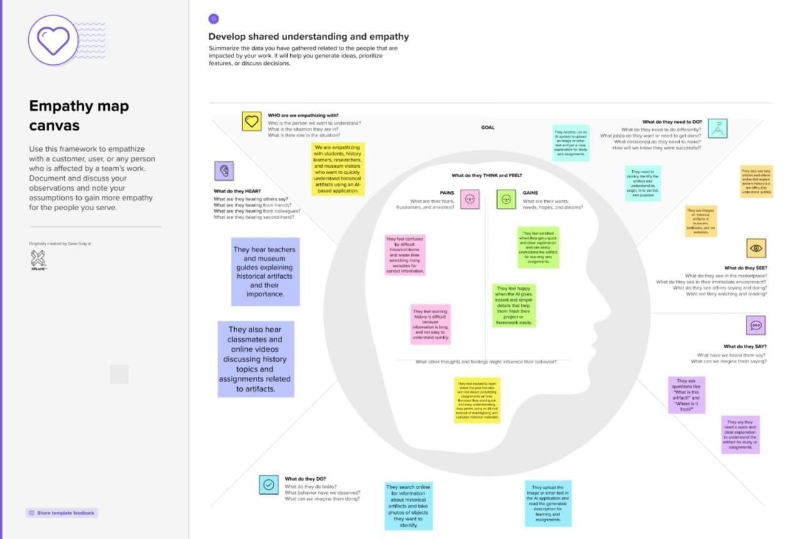

2.3 BRAINSTORMING
At the beginning of the project, we discussed real-life difficulties faced by students and learners while studying historical artifacts. Usually, when a person sees an ancient object such as a sculpture, coin, monument, or tool, they do not know its origin or importance. To understand it, they must search many websites, books, or videos. The information available online is often scattered, complicated, and written in difficult historical language. Because of this, beginners feel confused and spend a lot of time collecting data but still may not understand the artifact completely.
After identifying this problem, we thought about how technology can simplify the learning process. Since Artificial Intelligence and Generative AI models are capable of understanding both text and images, we decided to create a system that automatically explains historical artifacts. The idea was to allow users to either type a prompt or upload an image of an artifact. During idea prioritization, we selected the Gemini Historical Artifact Description project because it is useful, practical, and educational. The project combines AI, Natural Language Processing, and image understanding in a single web application.
The expected outcome of this brainstorming is a real-time AI application that improves learning efficiency and saves time. Instead of searching multiple sources, users can directly obtain structured information within seconds. The system also promotes awareness of cultural heritage and supports modern digital learning methods. Therefore, this idea was finalized as it effectively solves a
real-world educational problem using advanced AI technology.
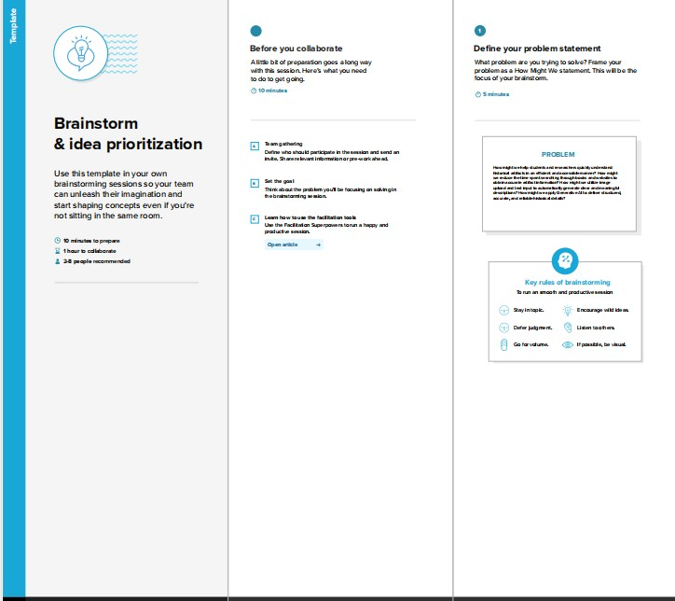

CHAPTER-3

REQUIREMENT ANALYSIS

3.1 CUSTOMER JOURNEY MAP:
The customer journey map describes how a user interacts with the Gemini Historical
Artifact Description System from the first visit to the final usage of the generated information. The process begins when the user opens the web browser and visits the Streamlit-based application. On the homepage, the user finds a simple interface with an image upload option and a text prompt field. The user uploads a picture of a historical artifact such as a coin, sculpture, or monument and optionally types a short query about it. After entering the input, the user clicks the “Generate Description” button to start the process.
In the engagement stage, the system sends the uploaded image to the Gemini Generative
AI model. The AI analyzes the object using image understanding and Natural Language
Processing techniques. The user waits a few seconds while the system processes the request. After processing, a detailed description appears on the screen. The generated output includes historical background, origin, time period, materials used, cultural significance, and interesting facts. The user reads the information and understands the artifact easily without searching external sources.
In the exit stage, the user copies the generated text or takes a screenshot for academic use. The information can be used in assignments, presentations, or project reports. Some users may share the generated results with classmates or teachers. This stage shows the practical usefulness of the system in real educational environments because it saves time and provides structured knowledge quickly.
In the extend stage, satisfied users return to the website again to analyze another artifact. They may recommend the system to friends or use it during seminars and project work. The application encourages repeated usage because it is easy to operate and provides understandable content. The system therefore supports continuous learning and awareness about cultural heritage.
Positive experiences in the journey include quick description generation, easy image upload, and beginner-friendly language. However, users may also face minor issues such as slow internet loading time, incorrect identification for unclear images, or difficulty choosing the right prompt. Future improvements can include multilingual output, audio narration, artifact category detection, downloadable PDF reports, and improved accuracy through better prompt guidance.

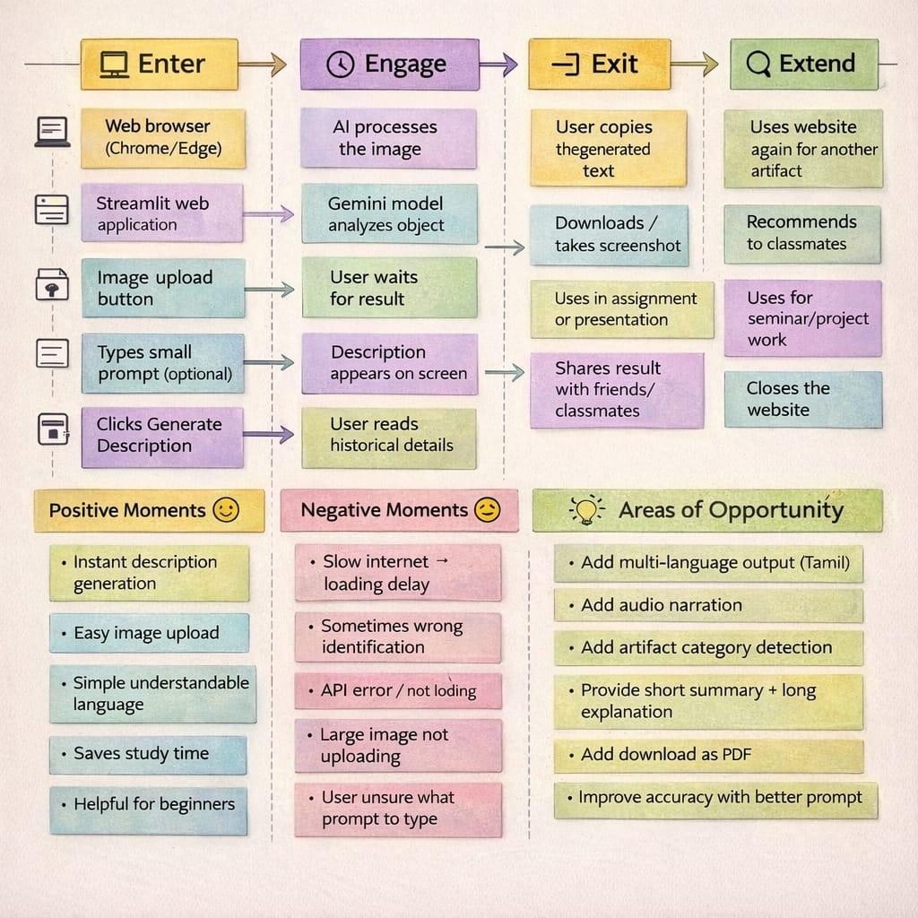

3.2 SOLUTION REQUIREMENT:
Functional Requirements:
The proposed solution is an AI-powered web application that allows users to generate detailed historical descriptions of artifacts using both image and text input. The system is accessed through a web browser and provides a simple and interactive user interface developed using Streamlit. After opening the application, the user can upload an image of a historical object such as a coin, sculpture, monument, or tool. The system also allows the user to enter a short prompt or artifact name to guide the AI in understanding the object more accurately.Once the input is provided, the application sends the image and text prompt to the Gemini Generative AI model for processing. The AI analyzes the visual features of the artifact and produces a structured description that includes origin, historical period, materials used, cultural significance, purpose, and interesting facts. The generated content is displayed on the screen in readable language so that even beginners or students without historical knowledge can understand it easily.
The system also includes error handling features. If the user fails to upload an image or if the API connection fails, the application displays an appropriate error message. During processing, the system informs the user that the description is being generated and may also show a short historical fact while waiting. This ensures continuous user engagement and improves the usability of the application.

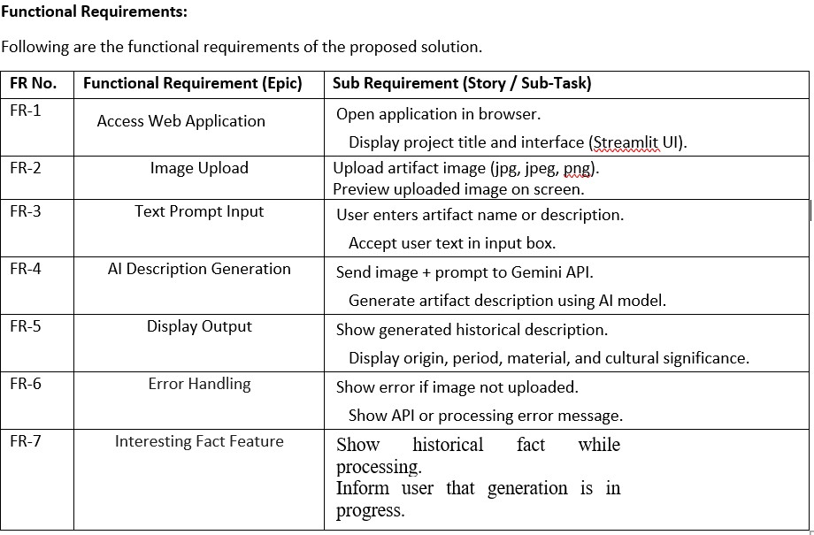

Non-Functional Requirements:
Apart from functional features, the system must satisfy several non-functional requirements to ensure quality and reliability. The application is designed with high usability so that users can operate it without training. The interface contains simple buttons, clear instructions, and a straightforward workflow for uploading images and generating descriptions.
Security is an important aspect of the system. The Gemini API key is stored securely in an environment configuration file and is not exposed in the source code or public repositories. This prevents unauthorized access and protects the system from misuse. The application must also be reliable and consistently generate outputs without crashing or producing empty responses. The performance of the system should allow the AI description to be generated within a few seconds after the user clicks the generate button. The application must remain available whenever an internet connection is present and the server is running. Additionally, the system should be scalable enough to support multiple users accessing the application simultaneously without significant delay or slowdown.

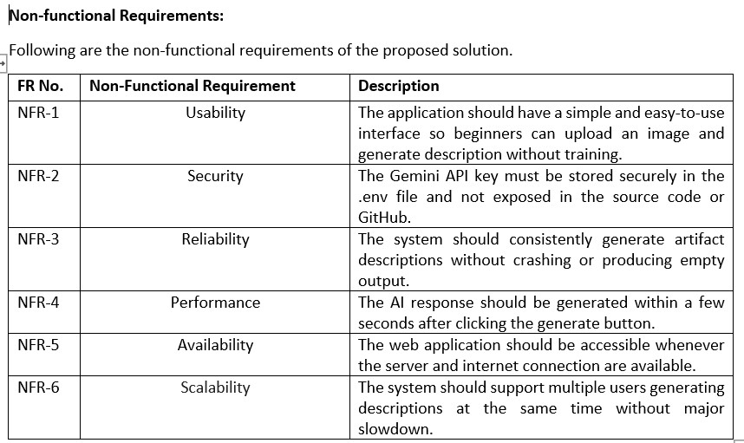

3.3 DATA FLOW DIAGRAM:
The Data Flow Diagram (DFD) represents how data moves through the Gemini Historical Artifact Description System. It shows how user input is received, processed by the application, analyzed by the AI model, and finally displayed as a structured historical description. The diagram
helps to understand the internal working of the system in a simple graphical manner by illustrating processes, data stores, and data flow between components.
At the beginning of the process, the user (student, researcher, or visitor) interacts with the web application through a browser. The user uploads an artifact image and optionally enters a short text prompt describing the object. This information is received by the Upload Input module. The uploaded image is temporarily stored in the system and the prompt text is saved as user input. These inputs act as the primary data required for generating the artifact description.After receiving the input, the system performs image processing. The application reads the uploaded image and converts it into a format suitable for AI processing. The processed image data along with the user prompt is then sent as a request to the Gemini Generative AI model. The AI model analyzes the visual characteristics of the artifact such as shape, texture, and patterns and combines it with the prompt to understand the context of the object.Next, the Gemini AI Processing module generates a detailed description of the artifact. The generated output contains historical information such as origin, time period, materials used, cultural significance, purpose, and interesting facts. This generated description is stored temporarily in the system as output data.
Finally, the Display Output module presents the generated description on the user interface. The user can read the historical details directly on the screen and use the information for learning, assignments, or research purposes. Thus, the DFD clearly shows the complete flow of data from user input to AI processing and final output display within the system.
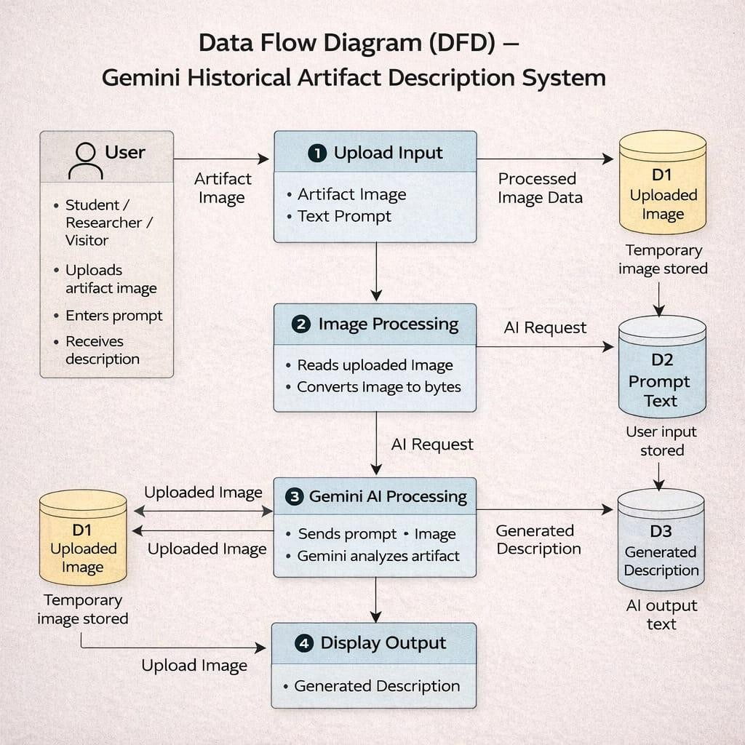

3.4 TECHNOLOGY STACK:

The Gemini Historical Artifact Description System is developed as a web-based application using a combination of modern web technologies, artificial intelligence services, and image processing libraries. The application follows a simple client–server architecture in which the user interacts with the system through a web browser, while the processing and AI analysis are handled by the backend application and external AI service.
On the user side, the system is accessed through a standard web browser such as Google Chrome or Microsoft Edge. The interface of the application is built using the Streamlit framework, which provides an interactive and easy-to-use graphical interface. The user can upload an artifact image and enter a short text prompt describing the object. The Streamlit interface includes buttons, input boxes, and image preview options, allowing users to easily interact with the system without requiring technical knowledge.
The backend of the application is implemented using the Python programming language. Python is used to handle image input, manage user requests, and communicate with the AI model. When a user uploads an image, the system processes the image using image-handling libraries such as PIL (Python Imaging Library). The image is converted into a suitable format and combined with the user prompt using prompt engineering techniques before sending it to the AI model.
For artificial intelligence processing, the system uses the Google Gemini Generative AI API as an external cloud service. The backend sends the processed image and text prompt to the Gemini API through an HTTP request. The AI model analyzes the visual features of the artifact and generates structured historical information including origin, time period, materials used, cultural significance, and interesting facts. The generated response is received by the backend and formatted into readable text.
Finally, the processed output is displayed back to the user through the Streamlit interface. The user can read the generated description directly on the screen and use the information for educational and research purposes. This technology stack ensures that the system is lightweight, easy to deploy, and capable of providing real-time AI-based historical artifact descriptions.

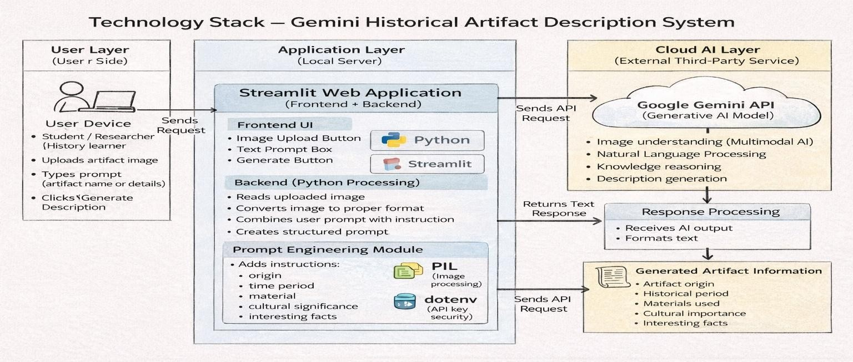

CHAPTER-4

PROJECT DESIGN

4.1 PROBLEM SOLUTION FIT:
The Gemini Historical Artifact Description System is designed after carefully analyzing the real problems faced by users while learning or identifying historical artifacts. The main target users of the system include students, teachers, researchers, museum visitors, and general history learners. Many students and beginners find it difficult to understand historical artifacts because the available information is scattered across textbooks, websites, and videos. Identifying an artifact requires searching through multiple sources, which consumes time and often creates confusion. Beginners especially do not know the correct keywords to search, and technical historical language makes understanding harder. As a result, users feel frustrated, waste time, and sometimes lose interest in learning history.
Currently, users depend on Google search, Wikipedia articles, YouTube videos, books, and teacher explanations. These methods require long reading and manual research. During exams, assignments, or seminar preparation, students struggle to quickly obtain clear information. When visiting museums or seeing an unknown artifact image online, users cannot easily identify the object or understand its historical importance. The root cause of the problem is the lack of a single platform that provides simple, instant, and understandable artifact explanations in one place.
To solve this issue, the proposed system provides an AI-based web application where the user only uploads an artifact image and optionally enters a short prompt. The system uses the Gemini AI model to analyze the image and automatically generate a structured description. The output includes the origin, time period, materials used, cultural significance, and interesting facts. This reduces manual searching and simplifies learning. After using the system, users gain clear understanding, save time, and become more confident in studying historical subjects.
The solution changes the user experience from confusion to clarity. Instead of reading multiple websites, users receive direct information within seconds. The application can be accessed through a web browser and used during assignments, classroom learning, seminars, or museum visits. Therefore, the system effectively fits the real user problem by providing a fast, easy-to-use, and educational AI-powered solution for understanding historical artifacts.

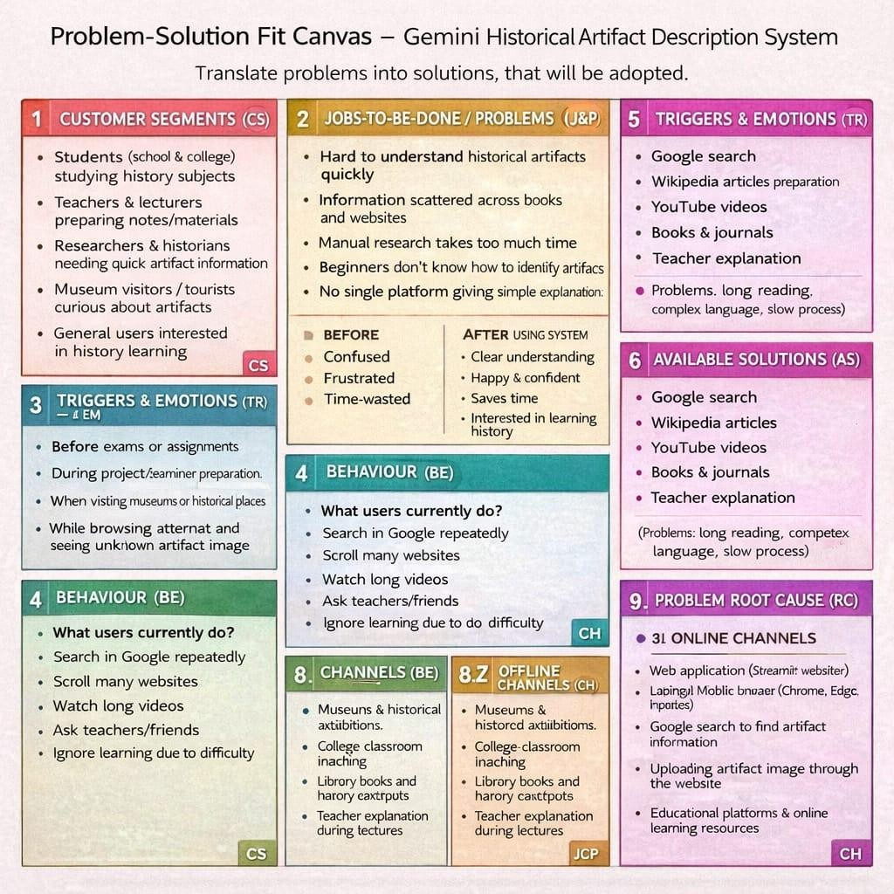

4.2 PROPOSED SOLUTION:
The proposed system, Gemini Historical Artifact Description System, is a web-based application developed to simplify the understanding and identification of historical artifacts. Many students and beginners face difficulty in learning history because they must search through multiple books, websites, and videos to collect information about a single artifact. The information is often scattered, complex, and written in technical language, which makes learning time-consuming and confusing. Therefore, the system aims to provide a single platform where users can easily obtain clear and structured historical information within seconds.The solution works by allowing the user to upload an image of a historical artifact and optionally enter a short text prompt describing what they want to know. The application processes the image and sends it along with the prompt to the Gemini Generative AI model. The AI analyzes the artifact and automatically generates a detailed explanation in simple and understandable language. The generated output includes the artifact’s origin, historical background, time period, material used, cultural significance, and interesting facts. The information is displayed instantly on the screen, reducing the need for manual research.
This system is unique because, unlike search engines, it does not only provide links to websites. Instead, it directly produces a complete explanation tailored to the user’s query. Even users without historical knowledge can understand the artifact easily. The platform supports students during assignments, teachers during lectures, and museum visitors who want quick information about displayed objects. By saving time and reducing effort, the system improves learning efficiency and encourages interest in history and cultural heritage.
From a practical perspective, the solution is scalable and can be expanded in the future. It can support multiple users simultaneously through cloud deployment and may include additional features such as multilingual output, downloadable reports, audio narration, and integration with museum databases. A freemium usage model can also be adopted, where basic features are free for students while advanced features are provided to institutions and organizations. Thus, the proposed solution provides an efficient, user-friendly, and intelligent platform for real-time historical artifact understanding.
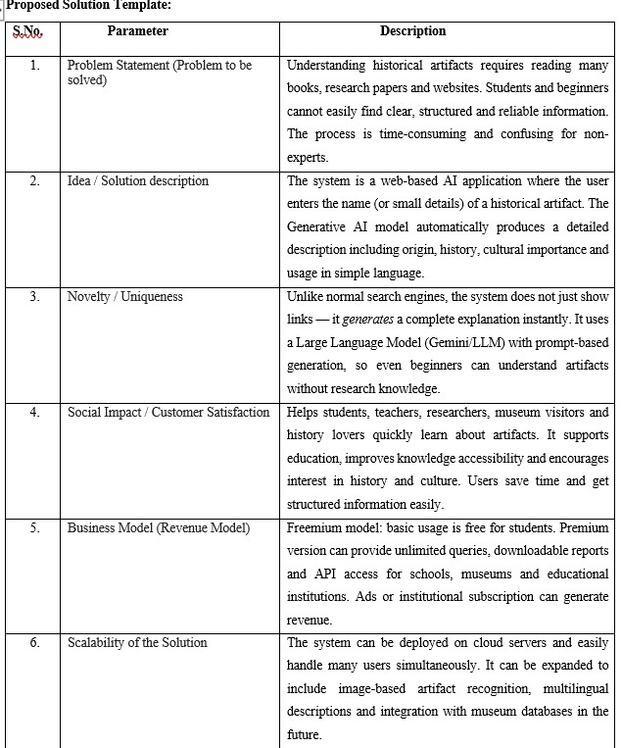
4.3 SOLUTION ARCHITECTURE:
The Gemini Historical Artifact Description System follows a layered architecture that
separates the user interface, application logic, artificial intelligence processing, and data storage. This structured design makes the system easy to understand, maintain, and expand in the future. The architecture mainly consists of four layers: Presentation Layer, Application Processing Layer, AI Processing Layer, and Data Storage Layer. Each layer performs a specific task and communicates with other layers to produce the final output.
The Presentation Layer represents the front-end interface through which the user interacts with the system. The web interface is developed using a Streamlit web application. In this layer, the user uploads an artifact image, optionally enters a prompt, and clicks the generate button. The interface displays the generated description clearly on the screen. This layer focuses on usability and ensures that even beginners can operate the system easily without technical knowledge.
The Application Processing Layer acts as the core controller of the system and is implemented using Python. It receives user input from the web interface and performs input validation, image preprocessing, and prompt construction. The server converts the uploaded image into a format suitable for AI processing and prepares a structured request. It then securely sends the request to the Gemini Generative AI API. After receiving the response, the server formats the output into readable text and sends it back to the user interface.
The AI Processing Layer uses the Gemini Generative AI model to analyze the artifact. The model processes both the image and the user prompt to identify the object and generate meaningful historical information. The AI produces structured details such as origin, historical period, material used, cultural significance, and interesting facts. This layer is responsible for the intelligence of the system and replaces manual research by automatically generating human-like explanations.
Finally, the Data Storage Layer stores uploaded images, generated descriptions, and user history. Temporary data may be saved for faster response and future reference. Storing results allows users to review previously generated artifact descriptions and helps improve system reliability. All layers work together through secure API communication, ensuring accurate results and fast performance.
Overall, the architecture provides a scalable and efficient solution. The modular design allows future improvements such as multilingual output, downloadable reports, museum database integration, and support for multiple simultaneous users. This architecture ensures the system is reliable, user-friendly, and capable of delivering real-time historical artifact explanations.

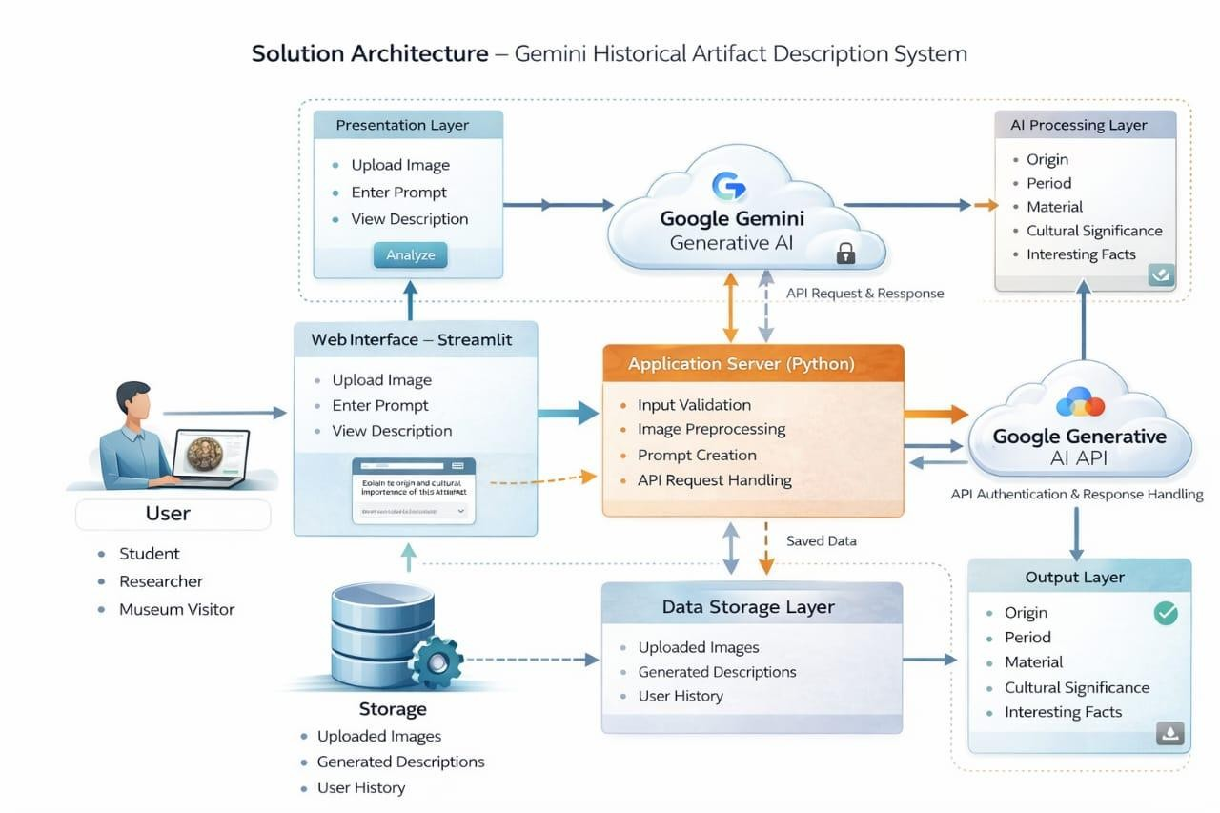

CHAPTER-5

PROJECT PLANNING & SCHEDULING

5.1 PROJECT PLANNING:
The development of the Gemini Historical Artifact Description System was carried out in a structured and organized manner using a simple software development lifecycle approach. The project work was divided into multiple phases such as planning, requirement analysis, design, implementation, testing, and deployment. Proper scheduling helped in completing the project within the academic timeline and ensured that each task was completed systematically.
During the planning phase, the project objective was clearly defined. The main aim was to develop an AI-based web application that can generate historical artifact descriptions using image input. The problem statement was identified by observing that students and beginners face difficulty in understanding historical artifacts and spend a lot of time searching information from books and websites. A development plan was created, tools were selected, and the working methodology was finalized.
In the requirement analysis phase, functional and non-functional requirements were collected. Functional requirements included uploading artifact images, entering prompts, generating descriptions using AI, and displaying the output to the user. Non-functional requirements included usability, security of API keys, system reliability, and fast response time. Based on these requirements, the system design and workflow were prepared.
During the design phase, system architecture diagrams, data flow diagrams, and customer journey maps were prepared. The interface layout was designed using Streamlit so that users could easily upload images and view results. The communication between the application server and Gemini AI API was also planned. This stage helped in understanding how each component of the system interacts with each other.
In the implementation phase, the application was developed using Python and Streamlit.
The image upload feature was implemented first, followed by prompt input and API integration.
The Gemini Generative AI API was connected to process the image and generate historical information. The system was tested continuously while coding to ensure proper functionality.
In the testing phase, different test cases were executed to verify the correctness of the system. Input validation, API connection, response time, and output accuracy were checked. Errors such as invalid input, image upload failure, and API response issues were handled properly. The performance of the system was measured to ensure that the response was generated within a few seconds.
Finally, in the deployment phase, the application was executed and demonstrated successfully. The generated descriptions were verified and documented. Necessary improvements were made based on testing results, and the final project documentation was prepared.

CHAPTER-6

FUNCTIONAL AND PERFORMANCE TESTING

6.1 PERFORMANCE TESTING:
Testing is an important phase of the Gemini Historical Artifact Description System. It ensures that the application works correctly according to user requirements and produces accurate results. The testing process was carried out in real-time after implementing each module of the system. The system was tested using different inputs such as valid images, invalid files, empty prompts, and network conditions to verify the behavior of the application.

- Functional Testing
Functional testing verifies whether each feature of the system operates as expected. Every function such as image upload, prompt input, AI processing, and output display was tested individually. The goal of this testing was to confirm that the system correctly accepts user input, processes the data through the Gemini AI model, and displays the generated historical description.
When the user opens the web application, the interface should load properly and show the upload option. After uploading an artifact image, the preview should appear on the screen. The user can optionally enter a prompt such as the name or details of the artifact. When the Generate Description button is clicked, the system sends the image and text to the AI model and displays the historical information including origin, period, material, and cultural significance.
Error handling was also verified. If the user clicks generate without uploading an image, the system displays a warning message. If an unsupported file format is uploaded, the system rejects it and asks for a valid image. If the internet connection fails or API response is unavailable, an appropriate error message is shown.

- Performance Testing
Performance testing evaluates the speed, responsiveness, and stability of the system under working conditions. The system was tested by uploading different image sizes and observing the response time. The primary goal was to ensure that the AI description is generated within a few seconds and the application does not crash.
The system performance mainly depends on internet speed and AI API response time. In normal network conditions, the description is generated within approximately 3–8 seconds. The system was tested multiple times continuously to check reliability. It was also verified that multiple users can access the application without major delay.
Large images were tested to observe system behavior. The application successfully handled medium-sized images, while very large images slightly increased response time but still produced correct output. Memory usage remained stable and the application did not freeze or stop during execution.

CHAPTER-7

RESULTS
7.1 OUTPUT SCREENSHOTS:
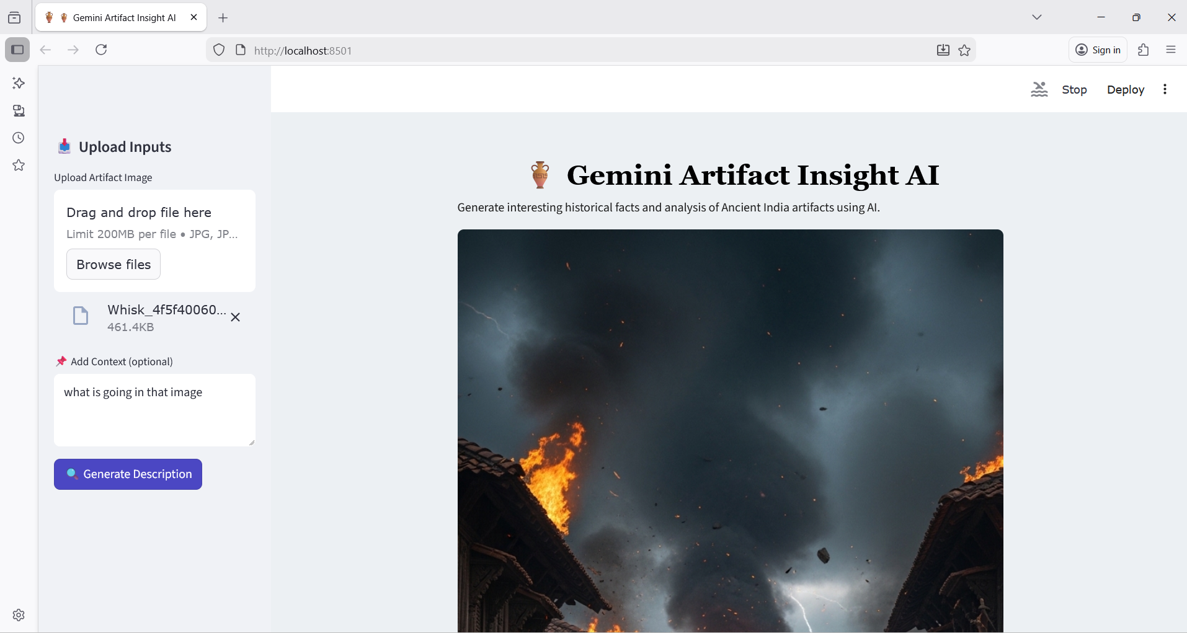

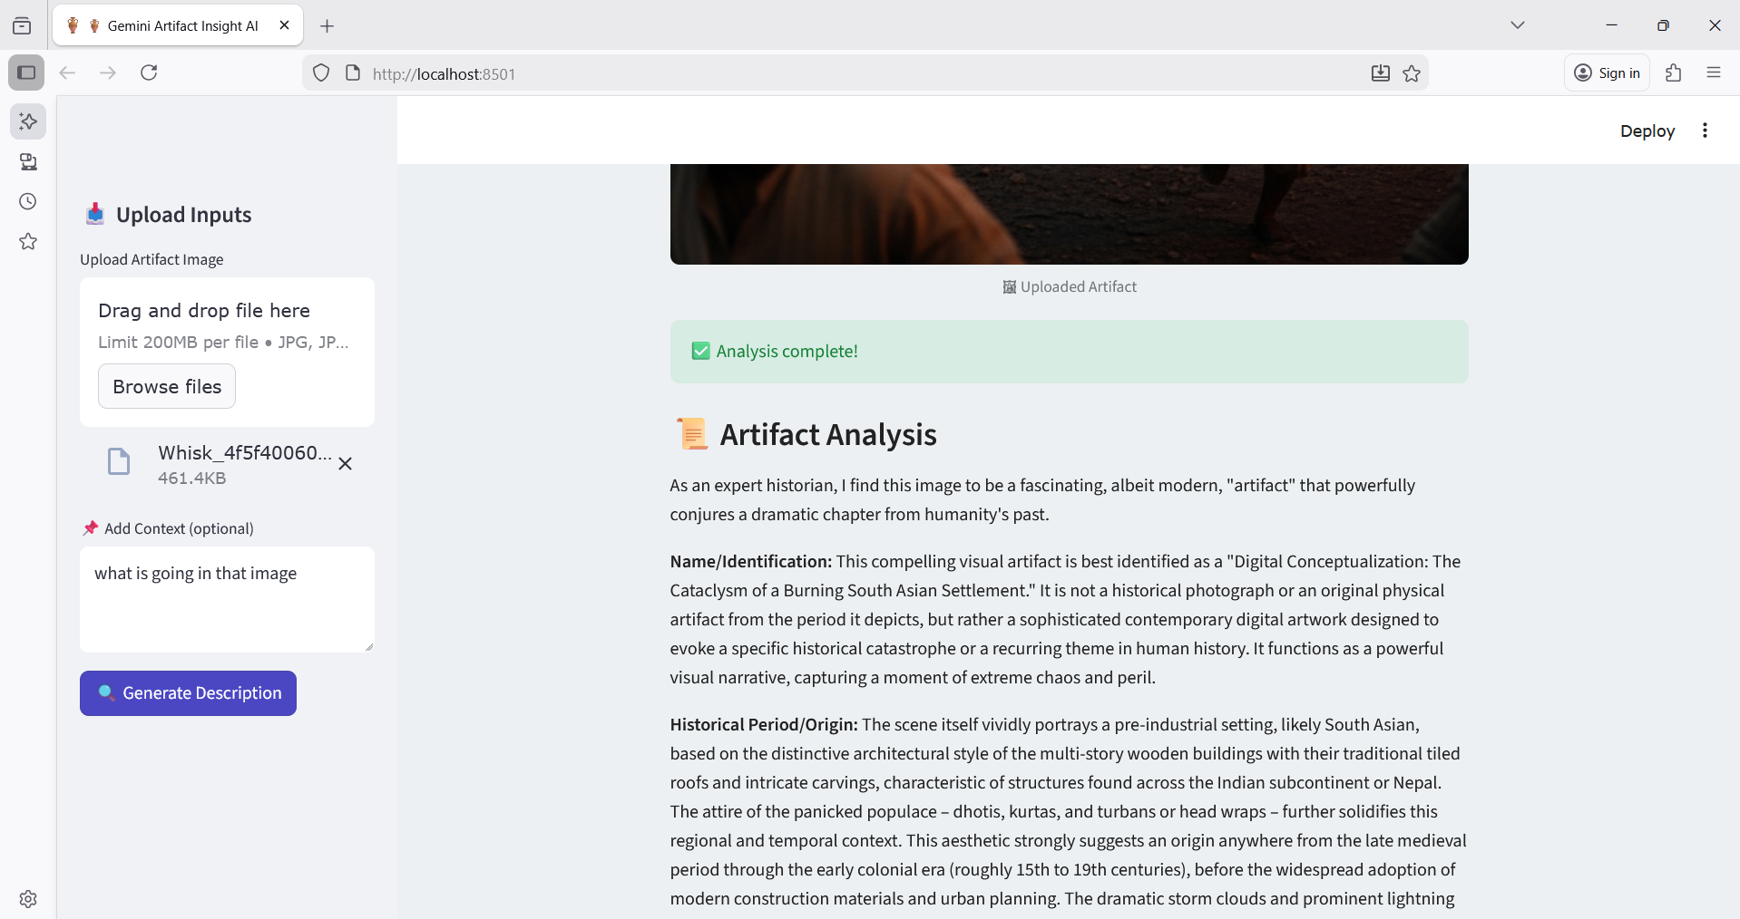

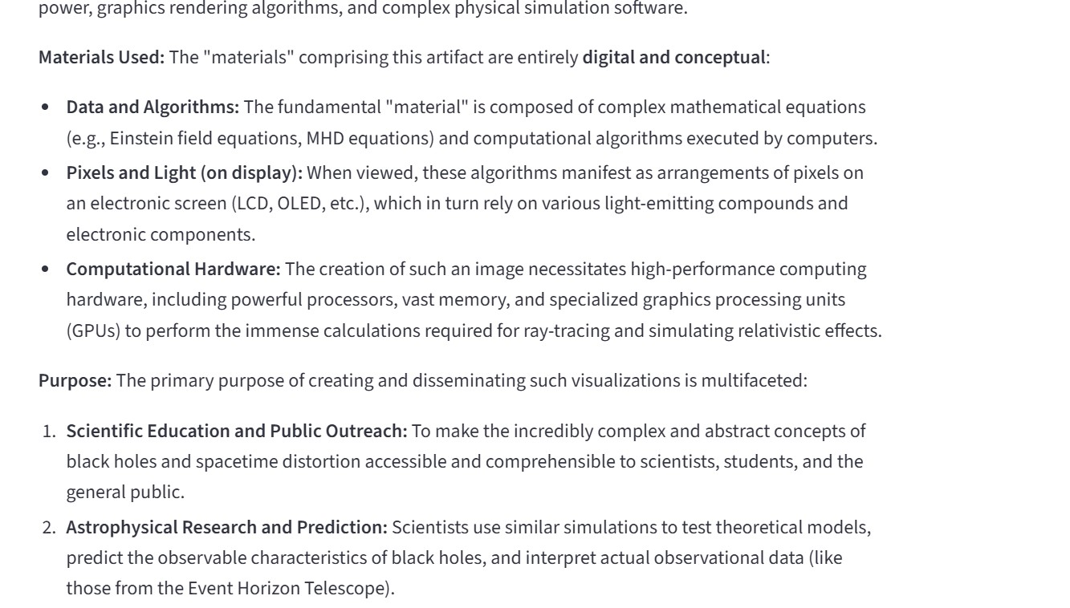

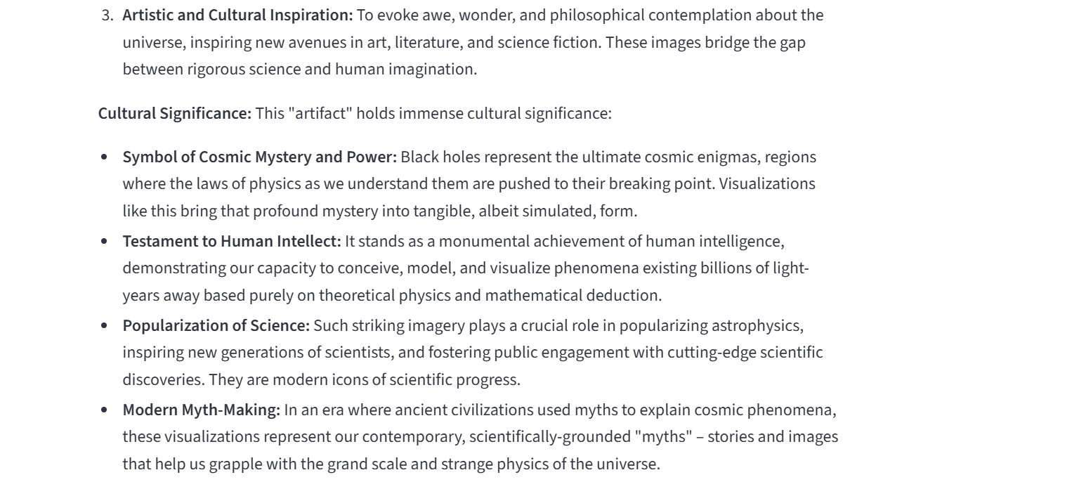

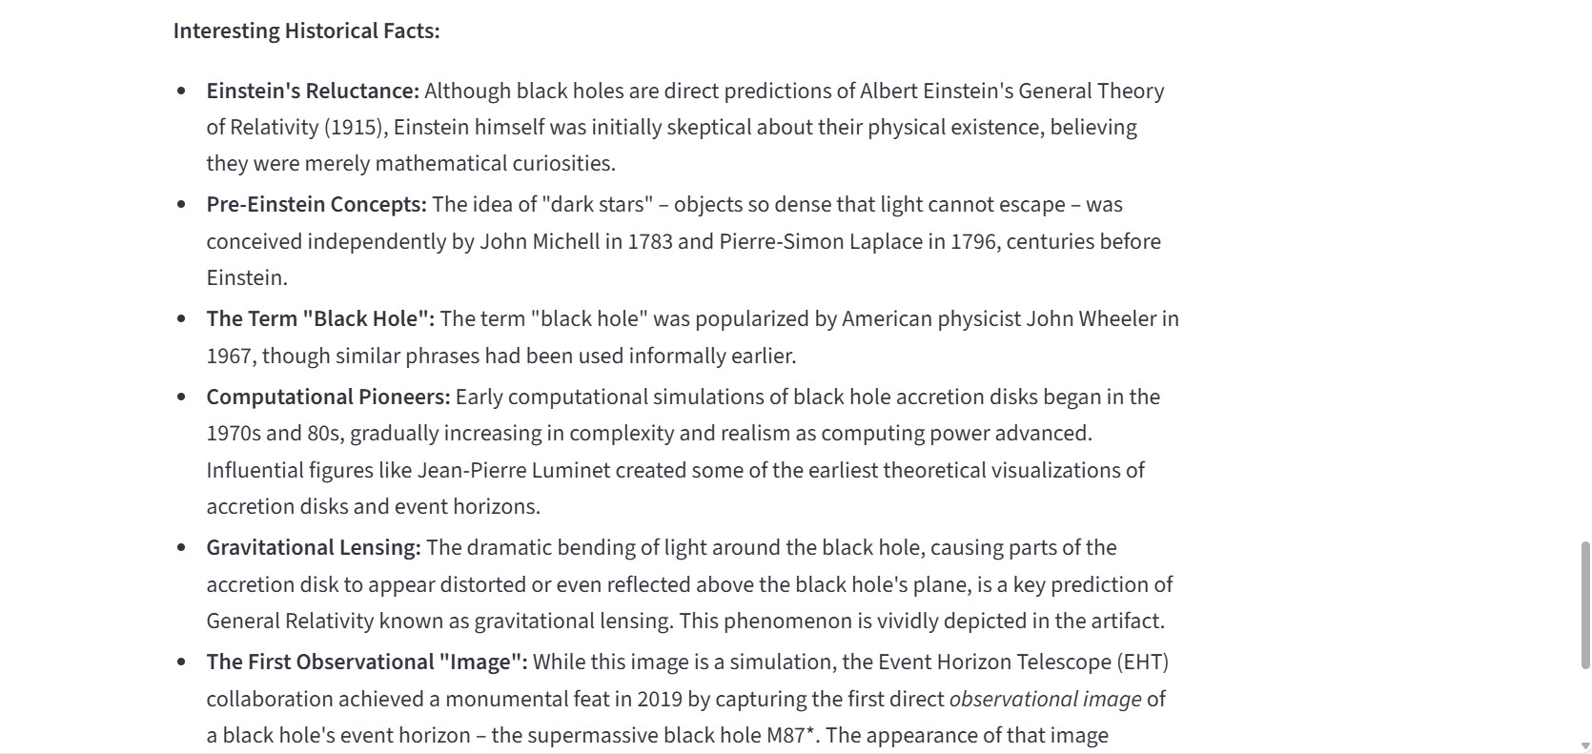

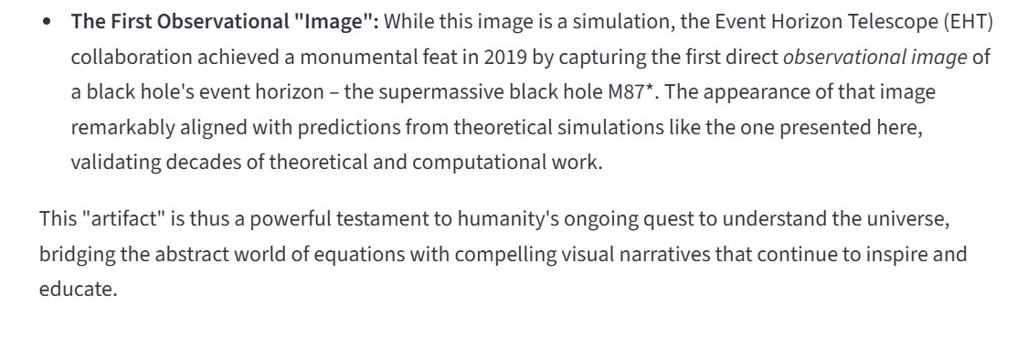

CHAPTER-8 ADVANTAGES & DISADVANTAGES

ADVANTAGES:
- Provides instant historical artifact descriptions using AI.
- Saves research time for students and researchers.
- Simple and user-friendly web interface.
- Generates structured information (origin, period, material, significance).
- Helpful for beginners who lack historical knowledge.
- Accessible from anywhere through a web browser.
- Reduces dependency on multiple books and websites.
DISADVANTAGES:
- Requires stable internet connection for AI processing.
- Depends on external API (Gemini), so downtime may affect usage.
- May sometimes generate slightly inaccurate information.
- Performance may reduce with very large image files.
- Limited features in basic version (if freemium model used).

CHAPTER-9 CONCLUSION

CONCLUSION:
The Gemini Historical Artifact Description System was successfully designed and implemented as an AI-based web application that helps users easily understand historical artifacts. The system allows users to upload an artifact image or enter a small prompt, after which the Generative AI model analyzes the input and produces a clear and structured description. The generated output includes important details such as origin, historical period, material used, cultural significance, and interesting facts. By combining a simple web interface with artificial intelligence processing, the application makes historical knowledge accessible even to beginners.
This project mainly focuses on reducing the time and effort required to search for information from books, websites, and research papers. Students, researchers, and museum visitors can quickly obtain meaningful information in one place without technical knowledge. The application also improves the learning experience by presenting information in simple language, which increases interest in history and culture. During testing, the system showed reliable performance, acceptable response time, and correct handling of user inputs and errors.
Overall, the proposed solution demonstrates how Generative AI can be applied in the education domain to provide smart and interactive learning support. The project achieves its objective of creating a user-friendly platform for artifact understanding and information retrieval. In the future, the system can be enhanced by adding multilingual support, audio explanations, artifact category detection, and integration with museum databases. Hence, the project proves that AI-based applications can significantly improve knowledge accessibility and make learning more efficient and engaging.

CHAPTER-10 FUTURE SCOPE

FUTURE SCOPE:
The Gemini Historical Artifact Description System can be further improved by adding new features and expanding its usability. Currently, the system generates artifact descriptions in a single language and through text output. In the future, multilingual support can be introduced so that users can read descriptions in regional languages such as Tamil, Hindi, or other international languages. Voice output can also be added to provide audio explanations, which will help visually impaired users and improve accessibility. This will make the application more inclusive and useful for a wider group of learners.
The system can also be enhanced by integrating advanced image recognition techniques to improve artifact identification accuracy. A trained dataset of historical artifacts can be included so the system can better recognize specific categories such as coins, sculptures, monuments, or tools. Additionally, the application may provide downloadable PDF reports, summaries, and references that students can directly use in assignments or presentations. A search history feature can also be implemented to allow users to view previously generated descriptions.
In the future, the project can be deployed on cloud platforms and converted into a mobile application so that users can access it anywhere using smartphones. The system can also be connected with museum databases and digital heritage collections to provide verified information about real artifacts displayed in museums. Augmented Reality (AR) support can be introduced so that users can scan an object using a mobile camera and instantly receive its historical explanation. These improvements will transform the system into a complete digital learning assistant for cultural heritage and history education.

CHAPTER-11

APPENDIX
SOURCE CODE:
The source code of the Gemini Historical Artifact Description System is provided in this appendix section. The application is implemented using Python and the Streamlit web framework. The main program file app.py contains the user interface, image upload handling, prompt processing, and integration with the Gemini Generative AI API to generate historical artifact descriptions.
The requirements.txt file lists all the required Python libraries and dependencies needed to run the application successfully. It allows any user to install the necessary packages using a single command and execute the project without configuration issues. These files ensure the project can be easily reproduced, tested, and deployed on another system.
Files Included
- app.py – Main application file containing Streamlit interface, image processing, and Gemini API integration.
- requirements.txt – Dependency file containing all required Python libraries (Streamlit, Google Generative AI library, Pillow, etc.).
How to Run the Project
  - Install Python (version 3.9 or above).
  - Download the project folder.
  - Open Command Prompt/Terminal in the project directory.
  - Install dependencies: pip install -r requirements.txt
  - Run the application:
streamlit run app.py
  - The web browser will automatically open and display the application interface.
app.py:
from dotenv import load_dotenv
import streamlit as st
import os
import google.generativeai as genai
from PIL import Image
#load environment variables from .env file
load_dotenv()
api_key = os.getenv("GOOGLE_API_KEY")
genai.configure(api_key=api_key) # Function to get Gemini response
def get_gemini_response(input_text, image, prompt): model = genai.GenerativeModel("gemini-2.5-flash")
response = model.generate_content([input_text, image[0], prompt])
return response.text
#Function to setup input image
def input_image_setup(uploaded_file): if uploaded_file is not None:
bytes_data = uploaded_file.getvalue()
image_parts= [
{
"mime_type": uploaded_file.type,
"data": bytes_data
}
]
return image_parts
else:
raise FileNotFoundError("No file uploaded")
#Initialize Streamlit app
st.set_page_config(page_title="Gemini Historical Artifact Description App", page_icon="🏺")
st.header("🏺 Gemini Historical Artifact Description App")
input_text = st.text_input("📝 Input Prompt:", key="input")
uploaded_file = st.file_uploader("🖼️ Choose an image of an artifact...", type=["jpg", "jpeg", "png"])
if uploaded_file is not None:
image = Image.open(uploaded_file)
st.image(image, caption="📷 Uploaded Image.", use_column_width=True)
submit = st.button("🚀 Generate Artifact Description")
input_prompt = """
You are a historian. Please describe the historical artifact in the image and provide detailed information, including its name, origin, time period, materials used, purpose, and cultural significance, and any interesting historical facts.
----
----

"""
# If submit button is clicked
if submit:
try:
image_data = input_image_setup(uploaded_file)
response = get_gemini_response(input_prompt + input_text, image_data, input_prompt)
st.subheader("📜 Generated Artifact Description:")
st.write(response)
except Exception as e:
st.error(f"⚠️ Error: {str(e)}")
requirements.txt:
streamlit
google-generativeai
python-dotenv
DATASET LINK:
The dataset contains sample historical artifact images such as statues, temples, sculptures and monuments collected for testing the Gemini Historical Artifact Description System. The images are used only for academic and demonstration purposes.
Reference:
https://drive.google.com/drive/folders/1BcG1TDySW9ym_IjdtbldXsuO2gXxROX7?usp=sharing
GITHUB & PROJECT DEMO LINK:
GitHub:
Reference:
https://github.com/jadaamruthalakshmi/Gemini-Historical-Artifact-Description
Project Demo:
Reference:
"C:\Users\TANA FOUNDATION\OneDrive\Desktop\Gemini_Historical_Artifact_App\Gemini-Historical-Artifact-Description-Amrutha\Demo Video\WhatsApp Video 2026-02-07 at 12.13.34 PM.mp4"

